**ABHISHEK SHARMA**

**500067644**

**R171218005**

**DATA COMMUNICATION AND NETWORKING LAB**

**EXPERIMENT NO. 8: -**

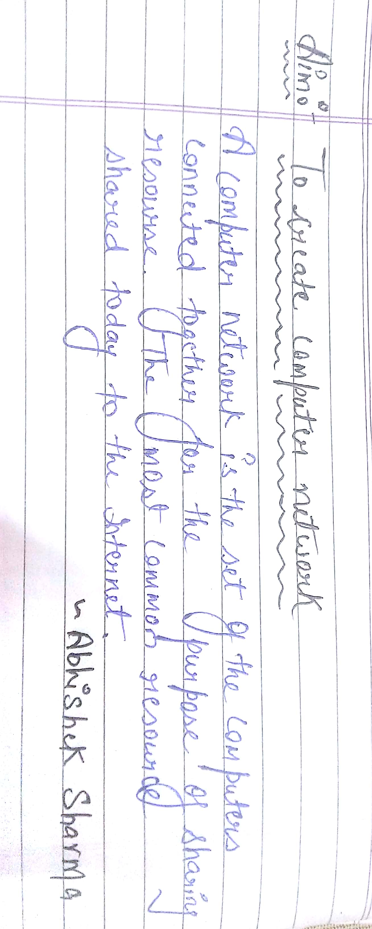

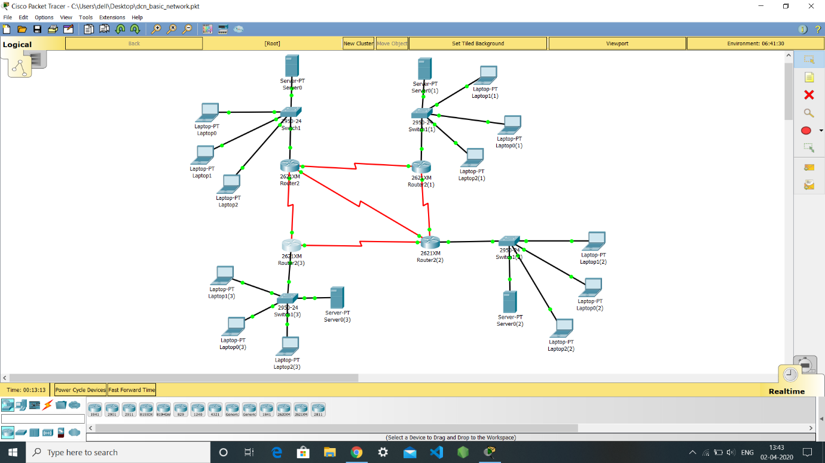

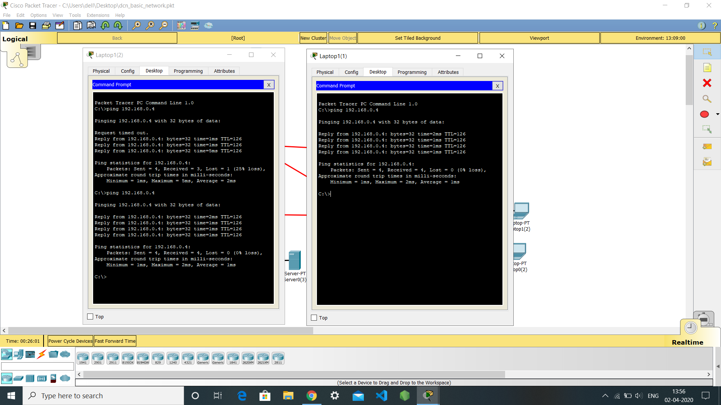

**EXPERIMENT NO. 9: -**

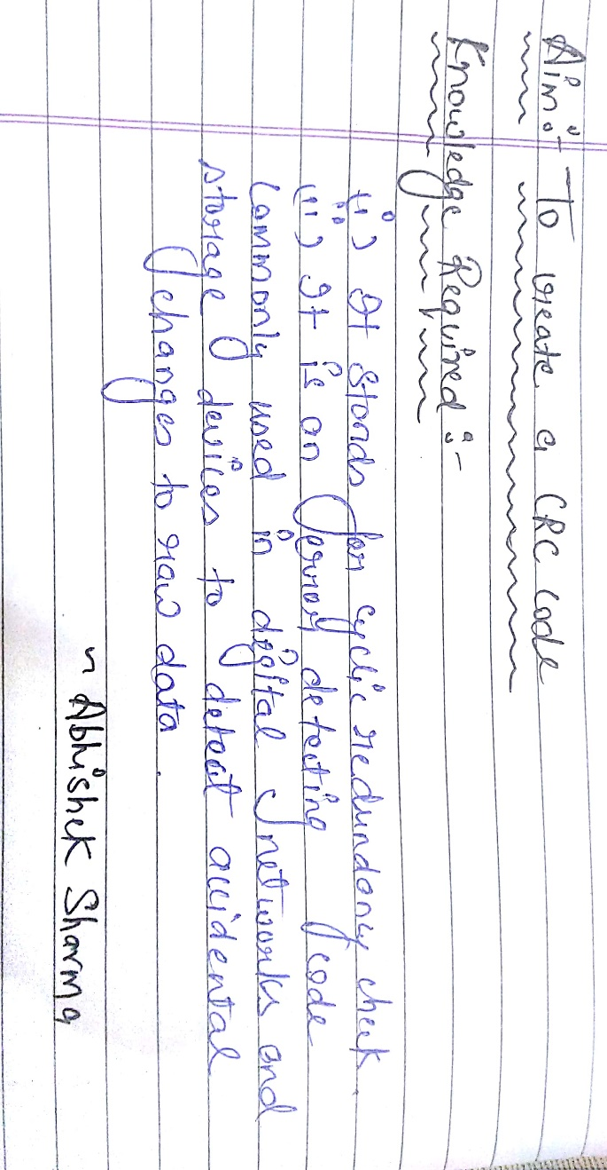

**Code: -**

#include<stdio.h>

#include<conio.h>

void main()

{

int i,f[20],n[50],div[50],j,temp,quotient[20],z[10];

printf("enter the number\n");

for(i=0;i<8;i++)

{

scanf("%d",&n[i]);

}

printf("enter the divisor\n");

for(i=0;i<4;i++)

{

scanf("%d",&div[i]);

}

for(i=8;i<12;i++)

{

n[i]=0;

}

for(i=0;i<8;i++)

{

temp=i;

if(n[i]==1)

{

for (j=0;j<4;j++)

{

if (n[temp]==div[j])

{n[temp]=0;

f[j]=0;}

else

{n[temp]=1;

f[j]=1;}

temp=temp+1;

}

quotient[i]=1;

}

Else

quotient[i]=0;

}

printf("\nthe quotient is \n");

for(i=0;i<8;i++)

printf("%d",quotient[i]);

printf("\n and the remainder is \n ");

for(j=0;j<4;j++)

printf("%d",f[j]);

getch();

}

**Output: -**

